Make A Difference
RSVP of Etowah & Cherokee County |  |  |  | October – December, 2021 Volume 20, Issue 4
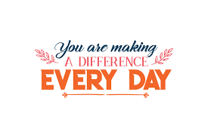  In the News  Reading Buddies  Unusual Recognition Event  Contents  Success Story 2  Volunteer Opportunities 2  Station Needs 2  Upcoming Events 3  Puzzle 3  Volunteer Recognition 4  Birthdays 5  RSVP Advisory Council 6 | The Retired and Senior Volunteer Program (RSVP) is a federal program charged with leading efforts to expand the use of service and volunteering as key solutions that respond to our nation’s most pressing challenges. Our mission is to improve lives, strengthen communities and foster civic engagement, through service and volunteering. RSVP is sponsored locally by the Etowah County Commission, and federally by the Corporation for National & Community Service (CNCS).

Director’s Corner
I’ve been going through old photos and the people and the times are all running together. How can everyone who was once so young and vibrant now have grey hair and bad knees?
Aren’t we all so lucky to have lived as long as we have, seen the things we’ve seen and done the things we’ve done? Some things I would never do again, but I don’t regret my experiences and life lessons.
There’s so much going on in our world today, but I hope you never forget the influence you have already had on countless people, the impact you continue to have on people every day, and the effect that this has on our neighborhoods, cities, towns, counties and this country.
Where would we be without you?
Nostalgia – that’s the autumn, dreaming through September. Just a million lovely things I will always remember. – Jackie Kennedy Onassis

September is definitely a dreamy, nostalgic time. Leaves are just beginning to change colors, the weather is cooling a little, school is in session, you don’t have to bundle up to watch a football game yet.

 | News
While some elementary schools are limiting the number of people coming into the building, some are not. We have Reading Buddies in place at many schools, but we still need volunteers who would like to help children learn to read and comprehend at Attalla Elementary, Glencoe Elementary and West End Elementary. If you know of someone in these areas who would like to work with children, help us spread the word!

We are going to have a recognition event (of sorts) for our volunteers this year, but nothing on the scale of what we normally do. We can’t, in good conscious, have an event with lots of people in close proximity and hugging and eating.

So – check your mail every day to see what we’re doing to show you some of the appreciation you so richly deserve!

Also, thanks to our anonymous benefactor the craft kits will continue! We are going to have one month dedicated to our recognition, which is for all of our volunteers, then you’ll see the craft kits again.
Life starts all over again when it gets crisp in the Fall.  ~ F. Scott Fitzgerald  - Etowah County Animal Shelter –Volunteers are needed to exercise and socialize with the pets that are up for adoption, or help in the office and answer phones.  - Etowah Free Community Clinic – volunteer dental hygienists and assistants are needed  - Etowah Baptist Missions Center – volunteers are needed to sort clothes. During this pandemic you do need to wear a mask, and gloves are encouraged for this activity!  - MANNA – volunteers are needed to deliver meals to homebound people. This only takes about an hour!  - .For these & other volunteer opportunities, call RSVP @ 256-549-8147!  STATISTICS  New volunteers – 2  Total volunteers – 235  Total stations – 51  Volunteer Hours – 4089  Value of Hours – $95,906.10  (According to federal guidelines, the value of a volunteer’s time is $20.84 per hour) | Success Story
So many volunteers have continued to work during this pandemic – all of you are success stories! But let me tell you about a fundraising event that RSVP volunteers helped with – the Council on Aging Speakeasy Casino Night. Six of our faithfuls came out to help on a Friday night and stayed till the bitter end. These guys helped with parking and set up and serving food and clean up. And because of their help the Council on Aging made money so that they can continue to serve ALL senior citizens with Medicare issues and some of our more vulnerable senior citizens with needs that no one else is helping with.

And do you know about all of the senior nutrition centers in Etowah and Cherokee Counties? And these volunteers are still helping at these places daily to make sure that seniors have at least one healthy meal each weekday.

“Quality is not an act – it is a habit.”

RSVP volunteers have this habit down pat!
 | Volunteer Opportunities
 | Volunteer Recognition
It is an honor for me to recognize three of RSVP’s unsung heroes. Mrs. Carol Hudson, Mrs. Ellie Higgins and Mrs. Dolly Thomas have spent many months and over 700 hours traveling the highway with me to deliver craft kits to our volunteers during this pandemic when many of the usual volunteer stations were closed. Thank you for the generous gift of your time and your heart – it’s been amazing!
~ Faye Russell, RSVP Volunteer Coordinator

The winner of our on-time, time sheet drawing is Mrs. Faye Shelton! Faye is a faithful volunteer at the Etowah Pregnancy Testing Center, with RSVP since 2007, and she has 1452 hours of service on record!

Upcoming Events
- October 7 – Choose Life event benefitting Etowah Pregnancy Testing Center. Call 256-442-6101 for info and tickets!  - October 15-December 7 – Medicare Open Enrollment period. For help or to make an appointment call Council on Aging at 256-492-0230.  - October 31 – Halloween  - November 7 – Daylight Savings Time ends. Remember to set your clocks back one hour.  - November 11 – Veterans Day    - November 25 – Thanksgiving  - December 9 – Smarter Seniors Workshop. Details coming soon!  - December 25 – Christmas  - December 31 – New Year’s Eve. |  |  | 

Word Search
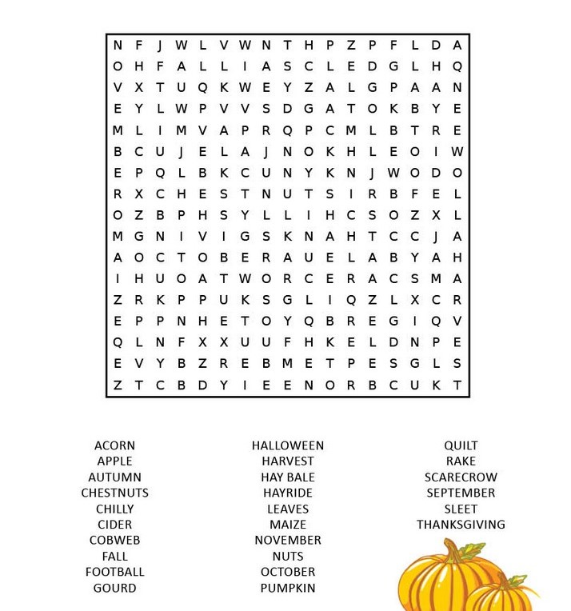

“Autumn – the season that teaches us that change can be beautiful.”  ~ Unknown   | Volunteer Stations
 | AARP, COOSA VALLEY CHAPTER  AMERICAN RED CROSS  ATTALLA HEALTH & REHAB  BIG BROTHERS BIG SISTERS  BOYS & GIRLS CLUB  CARVER SENIOR NUTRITION CENTER  CATHOLIC CENTER OF CONCERN  CENTRAL-CARVER MUSEUM  CHEROKEE COUNTY HEALTH & REHAB  CHEROKEE VILLAGE  CIRCUIT CLERK’S OFFICE OF ETOWAH COUNTY  CITY OF GADSDEN  COOSA VALLEY HEALTH CARE  COUNCIL ON AGING  EL SENOR CLUB  ELLIOTT SENIOR NUTRITION CENTER  ETOWAH BAPTIST MISSION CENTER | ETOWAH COUNTY COMMUNITY ACTION AGENCY  ETOWAH FREE CLINIC  ETOWAH HISTORICAL SOCIETY  ETOWAH PREGNANCY TESTING CENTER  EXTENDED FAMILY  FAMILY SUCCESS CENTER  FIRST CALL FOR HELP  FLOYD CHEROKEE MEDICAL CENTER  GADSDEN HEALTH & REHAB  GADSDEN PUBLIC LIBRARY  GADSDEN QUILTERS GUILD  GADSDEN REGIONAL MEDICAL CENTER  GEORGE WALLACE SENIOR CENTER  H D BUTTRAM SENIOR CENTER  HABITAT FOR HUMANITY  HEAD START | MANNA  MCGUFFEY HEALTH & REHAB  MOUNTAIN COVE  NORTHSIDE HEALTH & REHAB  PADEN RIDGE  PHYSICIANS WHO CARE  PILOT CLUB  READING BUDDIES  RIVERVIEW REGIONAL MEDICAL CENTER  RSVP ADVISORY COUNCIL  RSVP COMMUNITY SERVICE  RX HELP  SALVATION ARMY  SMARTER SENIORS WORKSHOPS  TAX COUNSELING  TELE CHEK  THE LOVE CENTER  UNITED WAY

HAPPY BIRTHDAY! |  |  | The older you get, the better you get. Unless you’re a banana.  ~ Betty White  
Sarah Trammell 10/01
Carolyn Jentzen 10/02
Betty Woodward 10/03
Jeanne Chambers 10/06
Connie Wappelhorst 10/6
Mary (Liz) Howell 10/08
Susan Wolford 10/10
Shirley Steapleton 10/12
Cynthia Toles 10/13
Betty Causey 10/14
Dianne Williams 10/18
Troy Word 10/20
Bess Estis 10/21
Bonnie Childs 10/22
Rose Higgins 10/24
Sonya Nesbitt 10/24

Theresa Beverly 10/25
Danny Phillips 10/26
Glenda Thornton 10/26
Ann Johnson 10/29
Barbara Mosley 10/29
Ellie Higgins 11/01
Ray St. John 11/04
Sherre McGinnis 11/11
Alma Alford 11/23
Treasia Spelce 11/24
Millie Cartrett 11/26
Jimmie Leonard 11/29
Rebecca Hilleke 11/30
Portia Foster 12/01
Dolly Thomas 12/02
Sally Shamblin 12/04
Kathy Blattel 12/05

Kenneth Mayo 12/07
Eloise Turk 12/07
Judy Smith 12/08
Rebecca Tinker 12/08
Sammy Griffin 12/13
Nina Tenerani 12/17
Maureen Latronico 12/18
Elizabeth Cline 12/20
Evelyn Westcott 12/21
Erma Davidson 12/22
Kenneth Means 12/22
Sandra Coffey 12/25
Frances Lipscomb 12/25
Steve Scharfenberg 12/26
Linda Ellison 12/28
Pat Hill 12/28
EllaJay Willis 12/29

We’re on the Web!  See us at:  www.etowahcounty.org  Friend us on Facebook!    https://www.facebook.com/groups/327258517069/  Follow us on Twitter!  Twitter.com/etowahrsvp  Follow us on Instagram!    @volunteers_of_etowah  Director – Traci Pondick  Van Driver/Volunteer Coordinator – Faye Russell  Admin. Asst./Reading Buddy Coordinator - Darlene Jones  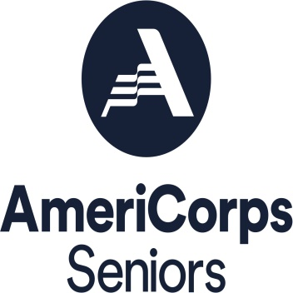  RSVP  800 Forrest Avenue  Room 219  Gadsden, AL 35901  Phone  256-549-8147  Fax  256-549-5351  E-mail  tpondick@etowahcounty.org  GETTING THINGS DONE. | RSVP Staff
 | RSVP Advisory Council
Chairperson –
Kenneth Hudson
Vice Chairperson – Portia Foster
Secretary/Treasurer –
Deborah Lankford

Theresa Frye
Jenifer Grace
Pat Hill
Carol Hudson
Judith Moon
Jeff Little

Craig Scott
Delma Smith
Cynthia Toles
Sarah Trammell
Towanna Wilson

Please shop at these local businesses & say “Thank You!” for supporting RSVP!

ABSOLUTE FITNESS | JOHNSON’S GIANT FOODS | RED LOBSTER
ACE HARDWARE | LEGACY DENTAL | REGIONS BANK
ADVANCE AUTO PARTS | LIFE INSURANCE  COMPANY OF AMERICA | RIVER BANK & TRUST
ADVANCE CARDIOVASCULAR | MYERS INSTITUTE OF HAND & PLASTIC  SURGERY | RSVP ADVISORY COUNCIL
ALABAMA TEACHERS  CREDIT UNION | NOCCALULA FALLS PARK | SMITH & BAILEY DENTAL
B & C TIRE | O’REILLY’S AUTO PARTS | BARONE’S PIZZA
BAKER TIRE | OBSERVER SUPPLY | SUPER BEE PHARMACY
DISCOUNT  PEST CONTROL | PEOPLES BANK | SUTTON BRIDGE  EXXON
EXCHANGE BANK | PEPPERMINT PONY | TAMING OF THE EWE
FAMILY SAVINGS  CREDIT UNION | PHYSICIANS HOME HEALTH SUPERSTORE | TOP O’ THE RIVER
GADSDEN FOOT CLINIC | PROFESSIONAL OPTICIANS | LINDA BARRETT-VAUGHN  REVENUE COMMISSIONER
 | PUBLIX | WAL-MART

